Install sonarqube and create rds:

# cd /opt

# wget <https://binaries.sonarsource.com/Distribution/sonarqube/sonarqube-6.7.6.zip>

# unzip sonarqube-6.0.zip

# mv /opt/sonarqube-6.0 /opt/sonar

sudo update-alternatives --config java

mysql -h sonarqubedb1.czjw6lpzdlon.ap-south-1.rds.amazonaws.com -usonarqubedb1 -p sonarqubedb1

Edit sonar properties file to uncomment and provide required information for below properties.

File Name: /opt/sonar/conf/sonar.properties

sonar.jdbc.username=sonar

sonar.jdbc.password=sonar

sonar.jdbc.url=jdbc:mysql://<RDS_DATABAE_ENDPOINT>:3306/sonar?useUnicode=true&characterEncoding=utf8&rewriteBatchedStatements=true&useConfigs=maxPerformance&useSSL=false

sonar.web.host=0.0.0.0

sonar.web.context=/sonar

Start SonarQube service

# cd /opt/sonar/bin/linux-x86-64/

# ./sonar.sh start

CREATE DATABASE sonar CHARACTER SET utf8 COLLATE utf8_general_ci;

Create a local and a remote user

CREATE USER sonar@localhost IDENTIFIED BY 'sonar';

CREATE USER sonar@'%' IDENTIFIED BY 'sonar';

Grant database access permissions to users

GRANT ALL ON sonar.* TO sonar@localhost;

GRANT ALL ON sonar.* TO sonar@'%';

check users and databases

use mysql

show databases;

SELECT User FROM mysql.user;

FLUSH PRIVILEGES;

QUIT

install java sudo yum install java-1.8.0

/opt/sonar/bin/linux-x86-64

Do changes in wrapper.conf file: /opt/sonar/conf

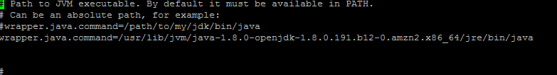

Install sonar plugins in Jenkins

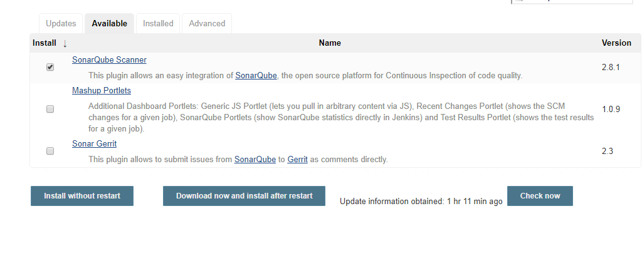

Go to sonarqube console with 9000 port and create token

Administrator---my account---security

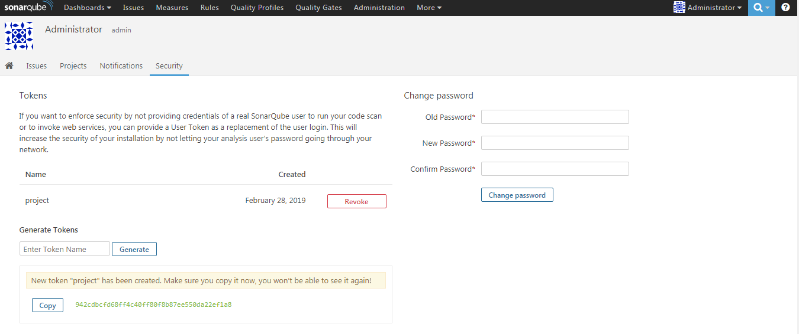

Go to Jenkins—manage Jenkins ---configuration system---

